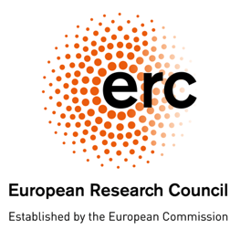

Concept Proposal

European Research Council (ERC) – Thailand PMU-B
Administrative Arrangement

A. Applicant Information
Name: ……………
Position: ……………
Affiliation: ……………
Address: ……………
Phone: ……………
Email: ……………

B. Selected Thematic Area
(Can select more than 1 thematic area of interest. Please see the Thematic areas from the “Call for Application”)
- ……………
- ……………
- ……………

C. Applicant Research Background Relating to the Thematic Area
(max 500 words)

…….

D. Why do you want to have collaborative research activities through research visits with EU-funded research teams? How can the collaboration further your research and your career? What are your expectations to achieve after the research visits? (max 500 words)

…….

E. CV (please attach your CV)

Please submit the Concept Proposal to PMU-B at pmub.gp@nxpo.or.th by 19 May 2023

